Output of this code

1.When we run our program on server:-

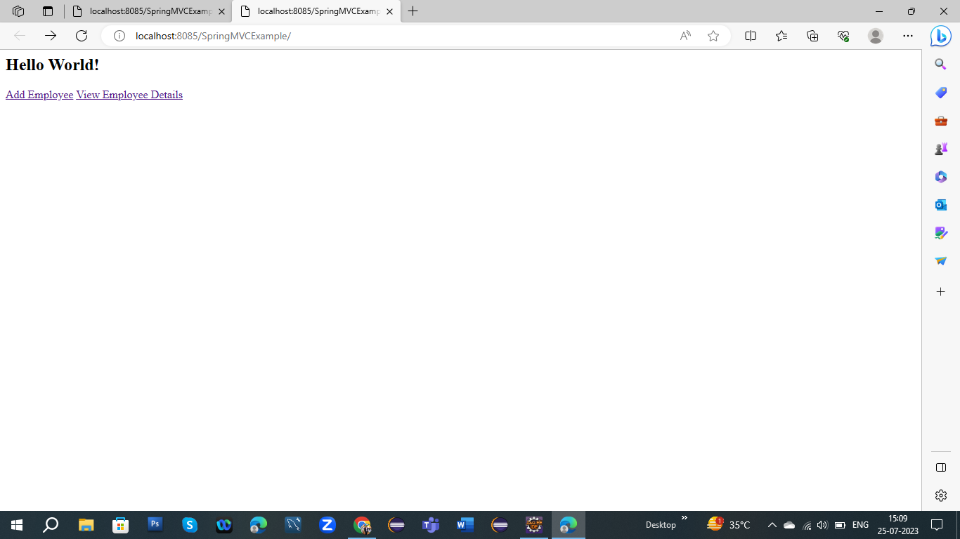

2.When we add our data in database:-

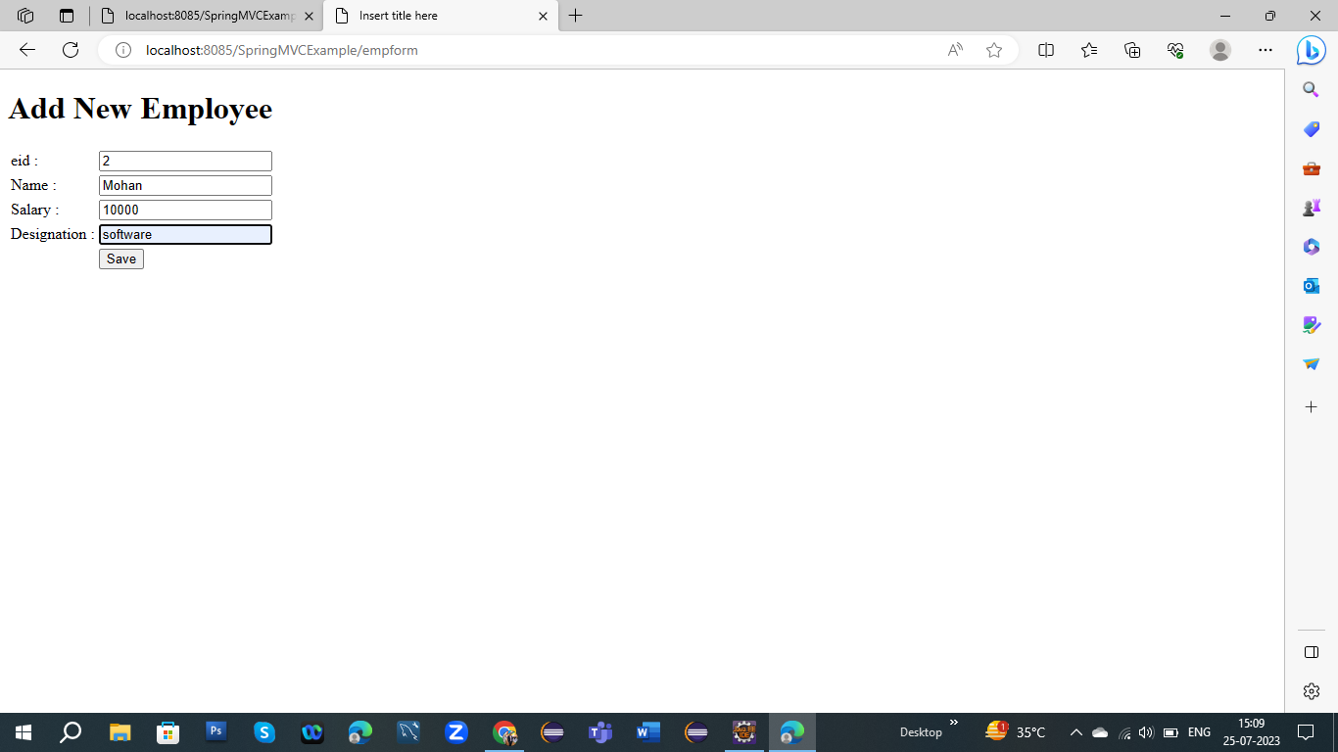

3.After adding data then we see our data:-

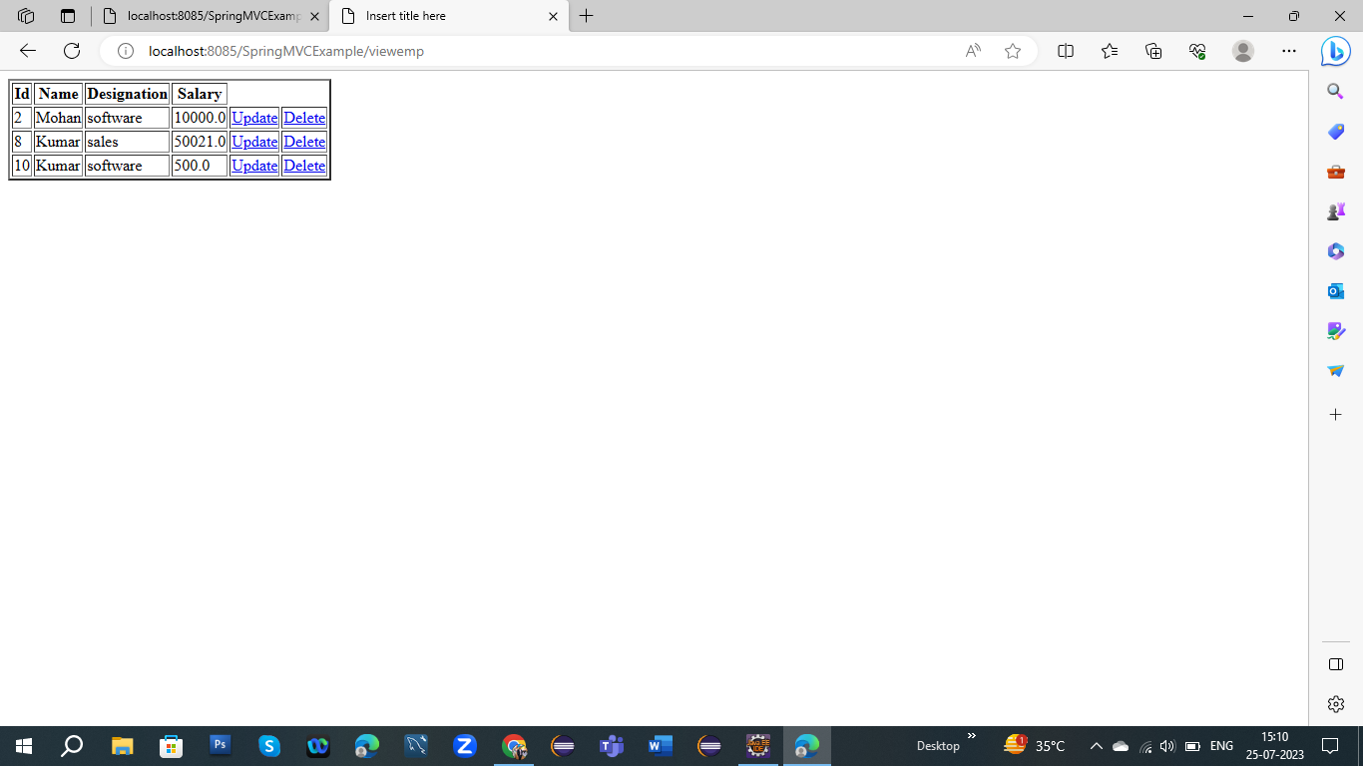

4.When we update our individual data in our database:-

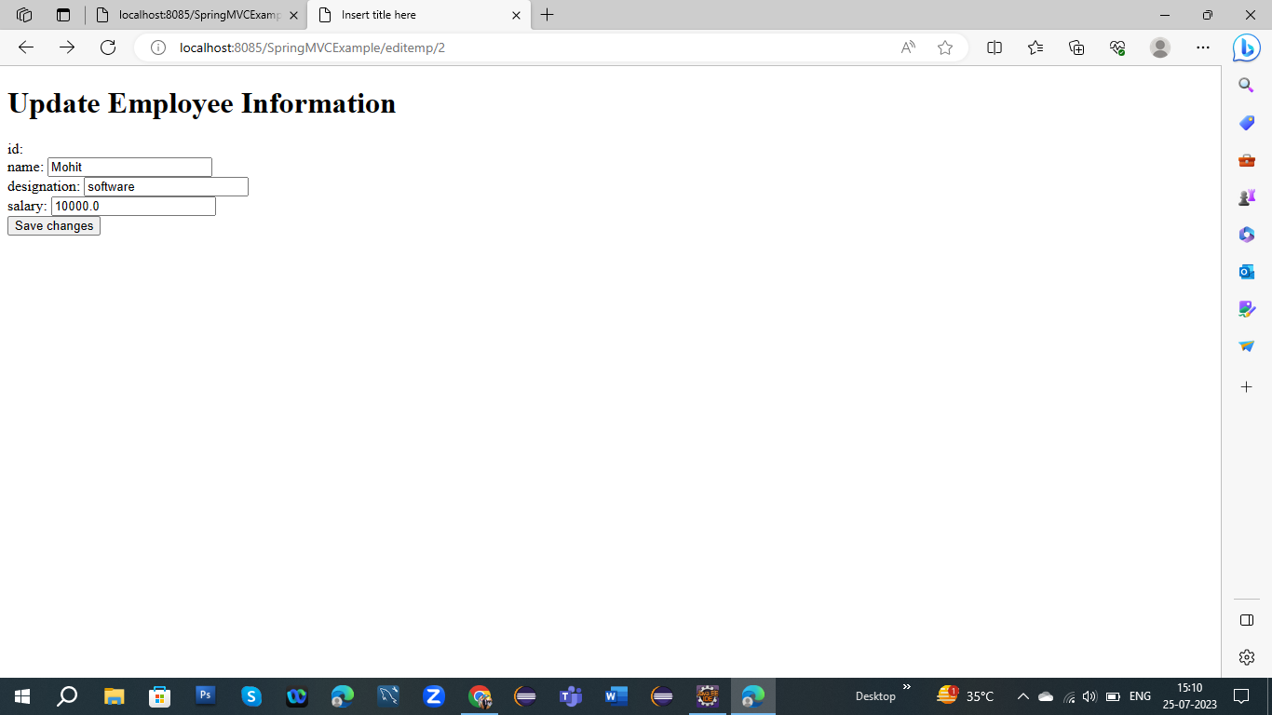

5.After updating the individual data in your database:-

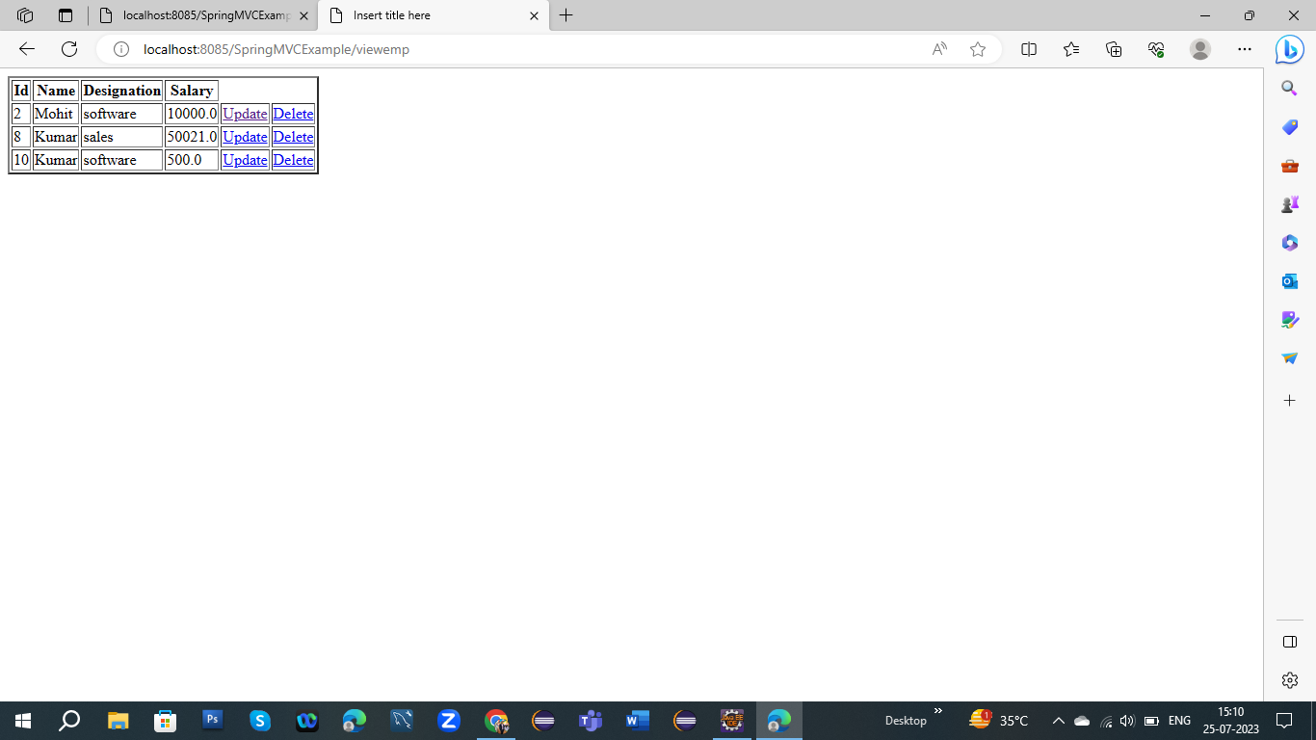

6.When we want to delete our particular row to using delete keyword:-

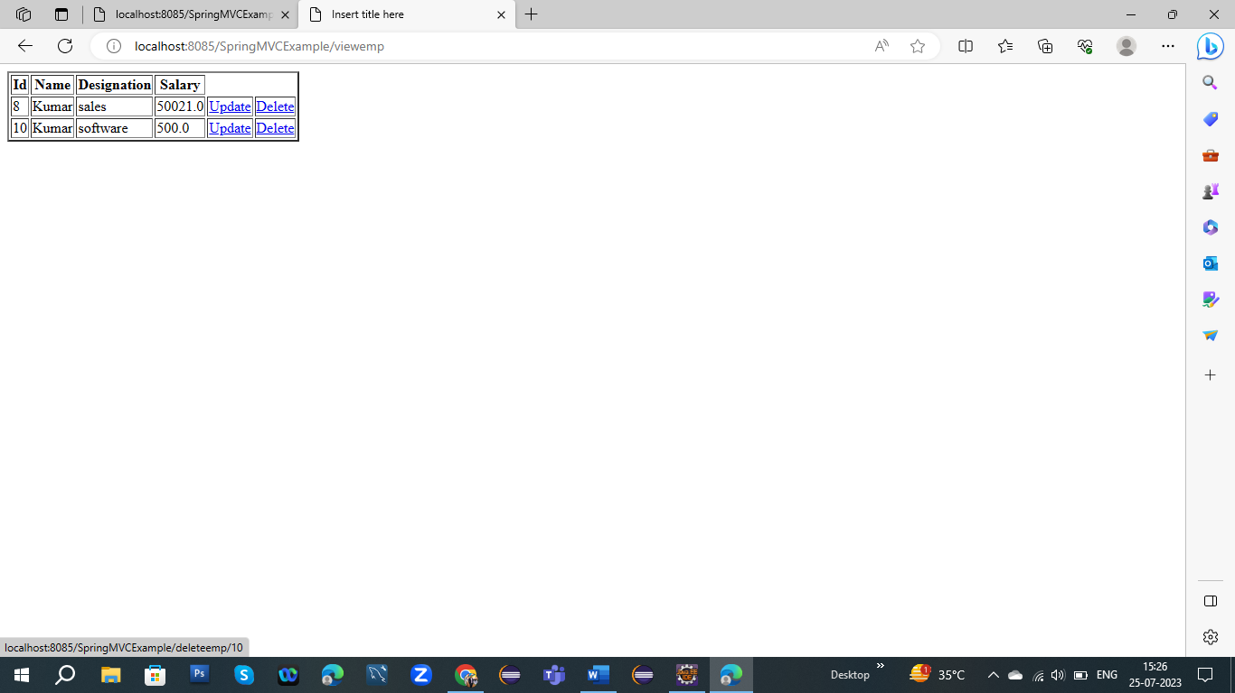

7.After deleting particular row in your database:-

